VR Guided Imagery for Stress Reduction

Kathy Guo, Patrick Capps, Alec Chesrown

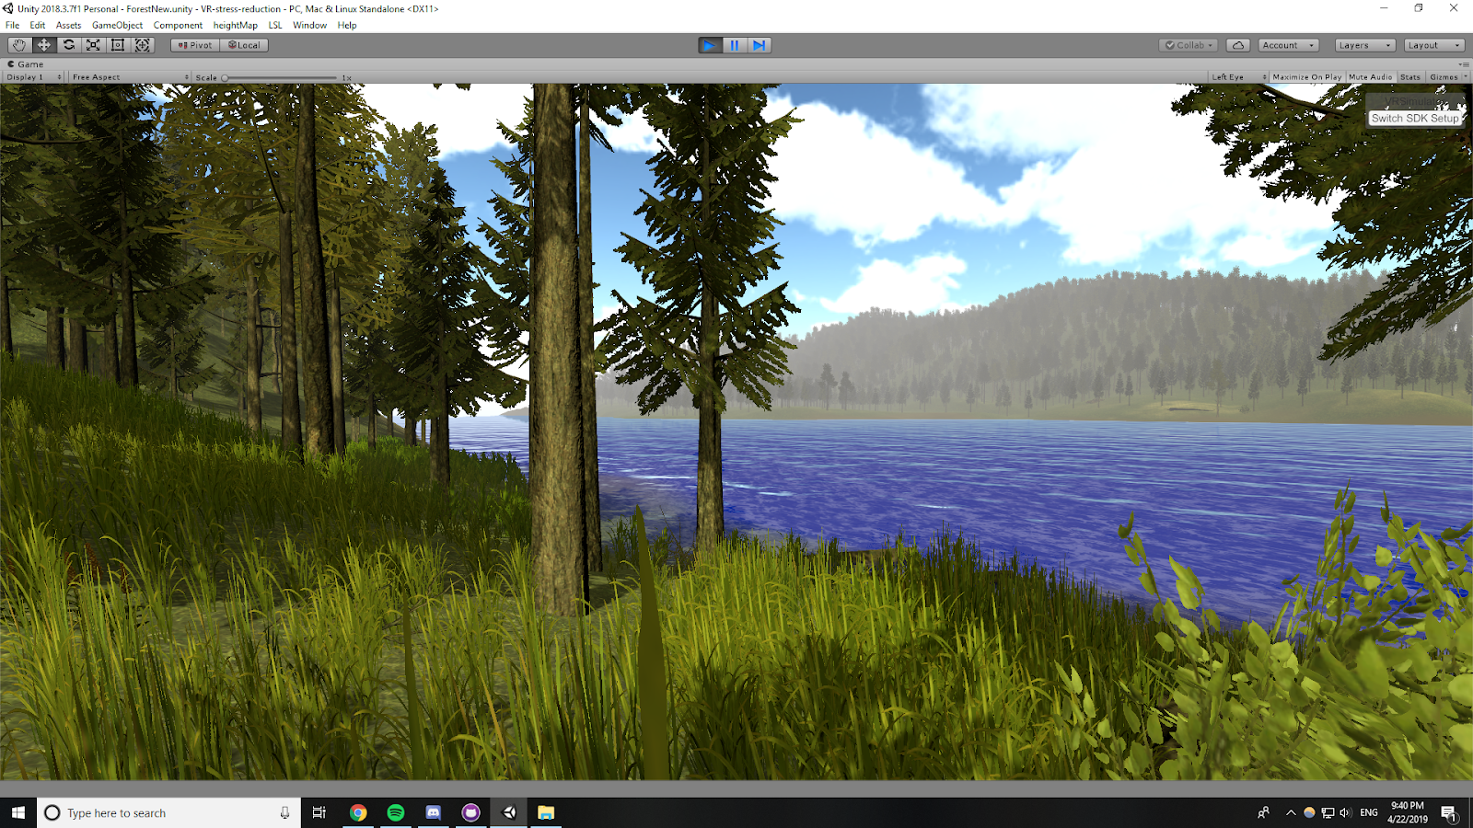

Fig. 1. Final forest scene with no color modulation.

**Abstract**—This is an interdisciplinary project to develop a VR guided imagery therapy that will relieve stress in people with stress-related health concerns, including chronic pains, anxiety, and high blood pressure. Using real-time biofeedback and guided imagery techniques, the VR system will allow users to explore a calming, forest scene while modulating scene lighting color in accordance with the users’ stress levels. Current components of guided imagery therapy are adapted to each individual. We aim to establish a generalized color-modulation model that will be effective in relieving stress for a broad range of users.

Introduction and Motivation

In 2017, the American Psychological Association reported that on average women experience a stress level of 5.1 (on a scale from 1 to 10) and men experience a stress level of 4.4 [6]. Based on 2016 data collected by the National Comorbidity Study Replication (NCR-S), 19.1% of U.S. adults had a form of anxiety disorder including generalized anxiety disorder, social anxiety disorder, and post-traumatic stress disorder (PTSD) [1]. The human body is designed to handle stress for short durations. However, long-term stress can deteriorate an individual’s health, causing secondary health complications like muscle pains, depression, and high blood pressure [4]. The effects of stress can have a significant impact a person’s quality of life and on society as a whole. For instance, individuals experiencing severe stress or anxiety may be unable to hold a job or have relationship problems. Therefore, it is important for individuals with chronic stress to adopt stress management strategies.

Guided imagery is a popular mind-body technique used to temporarily relieve stress and discomfort by directing the mind away from stressors. This project aims to create a guided imagery scene that will react to biometrics in order to find parameters that help the individual user de-stress. Each individual reacts uniquely to stimuli. For instance, one person may prefer to relax on a beach while another may prefer to go on a nature walk. However, there are also more universal stimuli that people find relaxing like the color blue and the sound of rain. Most guided imagery therapies used today are adapted to each individual’s preferences. However, there is need for a more generalized system with VR guided imagery since an in-person therapist may not always be available.

# Related Work

A 2008 study at the Ohio State University monitored “60 short-term hospitalized depressive patients,” some of whom were given CD-recorded guided imagery sessions for 10 consecutive days [2]. The study found that “the treatment group had significantly improved comfort and decreased depression, anxiety, and stress over time.” Another study on psychiatric inpatients showed that guided imagery and music (GIM) is an effective treatment for PTSD [3]. With the availability of VR technology, a technology-oriented guided imagery approach has emerged from the traditional guided imagery technique. Instead of having to rely on one’s imagination, VR guided imagery enables a user to virtually explore a location. In conjunction with music and voice guidance, the VR experience provides a more photo-realistic experience as well as the benefits of an in-person therapy session [5]. This technology will also enable users to access therapy outside of a therapist’s office such as at home or at work. There is also ongoing research on how individuals react to stimuli at the Ohio State University’s Technology for Mental Health research lab. The VR team is focused on finding a sound-modulation model using real-time heart rate variability (HRV) feedback that aims to relieve stress for a broad range of users. Similarly, we expanded on this research by designing a light-modulation model.

# Design Method

Many factors come into play when considering stress in the real world -- not just those of your immediate surroundings. But, for this project, the goal of the implementation is to get one to focus mainly on their surroundings. There are still many factors of one’s surroundings that will relate to stress, but we have chosen to focus specifically on color. In the real world, it’s not likely that the entire color of ambient lighting is going to shift to one end of the visible spectrum. In virtual reality, we have the opportunity to see how wavelength relates to an individual’s stress levels, and how it can be used to reduce them.

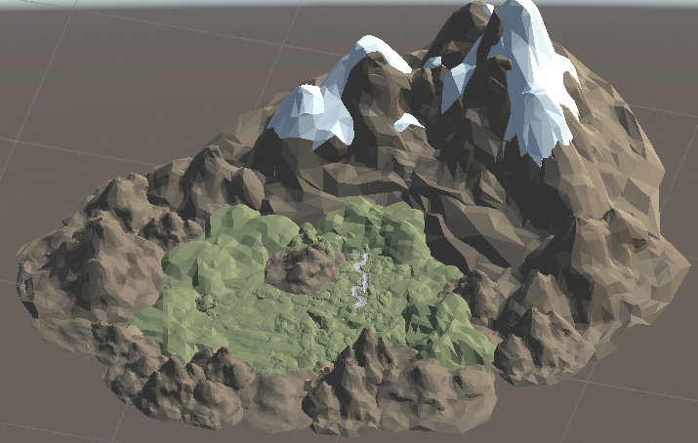The desired wavelength of light to reduce stress will vary from person to person. Generally, we expect to see that bluer wavelengths (shorter wavelengths) will reduce stress [9]. To monitor a user’s stress levels, we will track their heart rate variability during use. Heart rate variability is, over a period of time, inversely related to stress levels [8]. While the color of light will be related to a user’s stress level, the rendered scene in which they will be placed is also significant. In our earlier prototypes, we used a low-poly scene of a forest.

Fig. 2. First terrain implementation with low-poly assets.

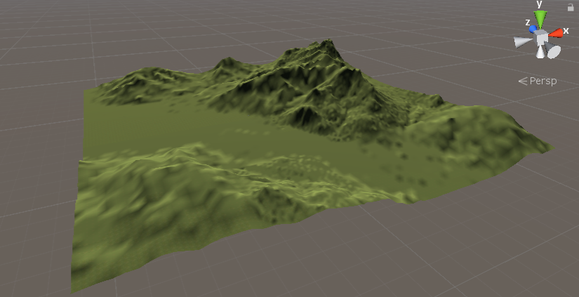After feedback from Dr. Passino, we decided to go in the direction of rendering a more realistic setting to more fully immerse our users in the setting. We shifted our focus on aspects of the forest, and of natural scenes in general, that are calming: daylight, high visibility, waterways, the sounds of animals, etc. For the terrain, we used the height map of a section of Yellowstone National Park to create a displacement map. In the rendered scene, we also included the sound of birds chirping, a flowing river, and the sun through the leaves and branches of trees, and so on.

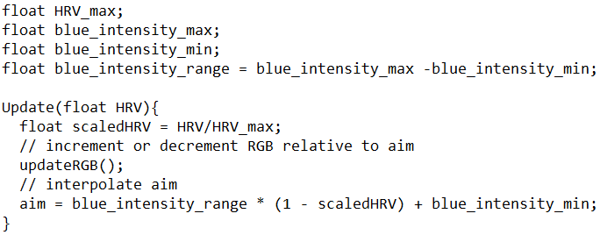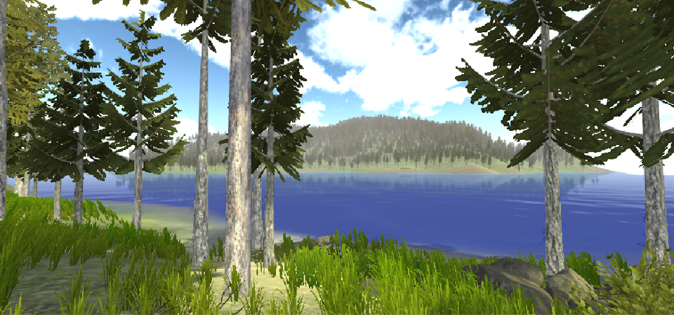Fig. 3. Terrain generated from displacement mapping.

Fig. 4. Terrain after the addition of some scene objects such as water, trees, grass, and rocks.

# Implementation Methods

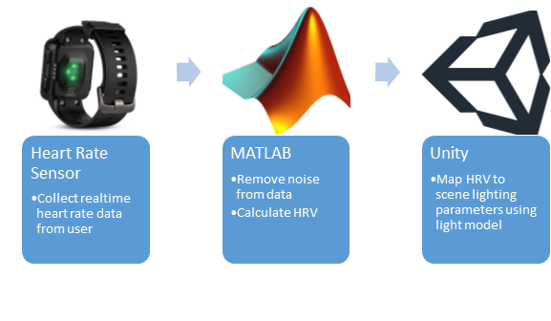We used Unity and C# to develop the forest scene using assets from the Big Environment Pack. For biometrics, we used a MATLAB script provided by the collaborators that cleans the raw data from a heart rate monitor and calculates the HRV across a moving time window. Using another Unity script from our collaborators, we were able to connect to the MATLAB data stream from Unity. The application is built to run on the HTC Vive using VR Toolkit. As a note, the controllers and base stations are still needed to calibrate the HTC Vive before use.

Fig. 5. Data flow and processing from heart rate sensor to Unity scene.

The evaluation on the effectiveness of this project is done by our collaborators, Locke Wang and Zhenghao Zhao, who are working on a similar therapy with sound modulation in a beach scene. The evaluations are included in the Results and Analysis section.

# Results and Analysis

This project will mainly address how color affects a user’s stress levels. Using literature on color and emotion, we designed a light modulation model to alter blue light in accordance to the user’s HRV data. Our collaborators have provided us with existing scripts to help us work with the biofeedback data. Using a MATLAB script provided, we took the raw heart rate data from a custom built heart rate sensor and filtered out the noise. Next, the script calculates the HRV using a sliding time window. Then, another Unity script reads from the HRV data stream from MATLAB and feeds the data into our model. See the Figure 5 in Implementation Methods that depicts this process.

The light model currently alters the directional sunlight within the scene. The ambient and diffused lighting from scene objects will also reflect the changes in color as the sun light will interact with the objects’ surfaces. Taking the scaled HRV which is a ratio of the HRV to HRV_max, the model linearly interpolates the RGB values of light source. Because we do not expect for the MATLAB script to remove all of the noise from the data, we wanted our model to be robust to fluctuations in HRV. This is important to our goal of immersing the user within the scene because sudden lighting transitions as a result of HRV fluctuations may seem jarring and may even create stress. In order to make lighting transitions smoother, we set the interpolated RGB value as a global AIM variable. With each scene update, we will increment or decrement the light’s current RGB values toward the AIM. A snippet of pseudo-code for this model is outlined below.

Fig. 6. Pseudo-code for updating the RGB values of the scene lighting.

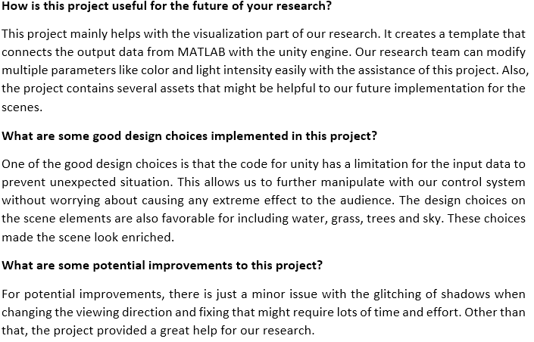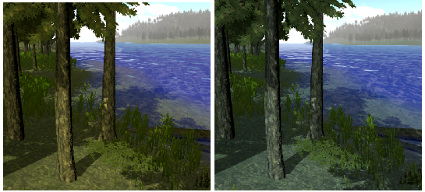Since the HRV is inversely related to stress, we picked our RGB values such that at low stress (high HRV), the scene would have natural, yellow sunlight. But at high stress (low HRV), the lighting will take on a blue tint to create a calming effect on the user. This figure compares the scene when user is at low stress vs at high stress.

Fig. 7. The scene lighting when user is experiencing low stress (left) vs high stress (right).

Fig. 8. Final scene with no color modulation.

The final product is a forest scene that can be rendered in virtual reality with Unity. Users can wear the Vive headset and the HRV watch to get the full experience of this application and have the scene color vary based on the user’s stress levels. When running the VR, we can also see how the HRV shifts in response to changes in the lighting from a time series plot made by a MATLAB script provided by our collaborators. This will allow us to gauge the effectiveness of the therapy in reducing stress.

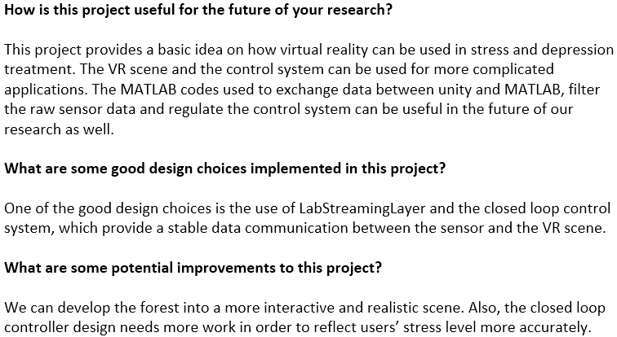In order to further evaluate the usefulness of this design, we asked two collaborators from the Technology for Mental Health research lab’s VR team for feedback. Our collaborators, Locke Wang and Zhenghao Zhao have been working on a similar application that involves sound modulation. We believe that they understand the background and requirements for this project well and can give us an informative evaluation. Comments from Locke and Zhenghao are shown below.

Fig. 9. Comments on the project from Locke Wang.

Fig. 10. Comments on the project from Zhenghao Zhao.

# Discussion of Results

As the ECE research team is still in the early stages of this problem space, our initial goal was to simply create a scene and modulate color based on the biometrics. We feel we successfully implemented a somewhat realistic forest scene in VR and that the color modulation is a solid foundational algorithm for the team to work on. The research team’s comments suggests it satisfied their requests as they will be able to modify light parameters and that the scene has “favorable” design. Of course, while the scene is a good start, it could be made even more realistic with higher quality art assets and improved design. They also suggest making it more interactive, so VR interaction could be added to allow the user to move around the scene and interact with plants or animals.

# Conclusions and Future Work

In the future this project will hopefully be tested on real users, but due to time constraints and the research being in early phases this was not feasible. Real, varied user testing is a necessity in the future of this project. Before testing happens, there should be some improvements to the model based on the feedback of Zhenghao Zhao and Locke Wang. The scene itself needs to be made more immersive, as they both stated, there are currently issues with the realism of the forest scene. This alone could take a potential user out of a focused state and into a stressed one. Also, as Locke stated, the controller design needs to be improved. A comparison will need to be made between our work and the work of Zhenghao and Locke, and they will decide how to combine their work with ours. We hope that we have provided the researchers with a foundation to continue work in this area and reach a stage where user testing is appropriate.

# Team Contacts

|  |  |  |
| --- | --- | --- |
| **Name** | **Role** | **Email** |
| Dr.Kevin Passino | Client/Expert | passino@ece.osu.edu |
| Kathy Guo | Developer | guo.901@osu.edu |
| Patrick Capps | Developer | capps.19@osu.edu |
| Alec Chesrown | Developer | chesrown.4@osu.edu |

References

1. Any Anxiety Disorder. (2017, November). Retrieved March 1, 2019, from https://www.nimh.nih.gov/health/statistics/any-anxiety-disorder.shtml
2. Apóstolo, J. L., & Kolcaba, K. (2009). The Effects of Guided Imagery on Comfort, Depression, Anxiety, and Stress of Psychiatric Inpatients with Depressive Disorders. Archives of Psychiatric Nursing,23(6), 403-411. doi:10.1016/j.apnu.2008.12.003
3. Blake, R. L., & Bishop, S. R. (1994). The Bonny Method of Guided Imagery and Music (GIM) in the Treatment of Post-Traumatic Stress Disorder (PTSD) with Adults in the Psychiatric Setting. Music Therapy Perspectives,12(2), 125-129. doi:10.1093/mtp/12.2.125
4. Chronic stress puts your health at risk. (2016, April 21). Retrieved from https://www.mayoclinic.org/healthy-lifestyle/stress-management/in-depth/stress/art-20046037
5. Dayang, R., Awang, R., Suziah, S., Halabt, H., Abas, S., Peteras, B., & Mohd, Y. (2011). VReST: An image-based virtual reality stress therapy web application [Abstract]. 2011 IEEE International Symposium on IT in Medicine and Education. doi:10.1109/itime.2011.6132104
6. Stress in America: The State of Our Nation[PDF]. (2017, November 1). American Psychological Association.
7. Jönsson, Peter. “Respiratory Sinus Arrhythmia as a Function of State Anxiety in Healthy Individuals.” International Journal of Psychophysiology, vol. 63, no. 1, 2007, pp. 48–54., doi:10.1016/j.ijpsycho.2006.08.002.
8. Nickel, Peter, and Friedhelm Nachreiner. “Sensitivity and Diagnosticity of the 0.1-Hz Component of Heart Rate Variability as an Indicator of Mental Workload.” Human Factors: The Journal of the Human Factors and Ergonomics Society, vol. 45, no. 4, 2003, pp. 575–590., doi:10.1518/hfes.45.4.575.27094.

[9] Minguillon, Jesus, et al. “Blue Lighting Accelerates Post-Stress Relaxation: Results of a Preliminary Study.” Plos One, vol. 12, no. 10, 2017, doi:10.1371/journal.pone.0186399.